
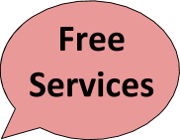

DRIVING IN ALBERTA

South Side Settlement Program is hosting a workshop “Driving in Alberta”

The workshop will include:
- Becoming a Driver in Alberta
- Driver`s guide to operation, safety and licensing
- Responsibilities of owning a vehicle
- Visitors Driving in Alberta (Out of Country License)
- Other types of Registry Services
- Tips on winter driving

Date: Sep 05, 2013
Time: 1:00 pm to 3:00 pm
Location: 11016-51 Avenue
Fee: FREE
Language: English
Max Seating: 30
Registration: Required
Coordinator: Sadia Anwar
Guest Speaker: Najla Hussein (Alberta Service Bureau)

For more information please contact (780) 429-3119.

South Side Settlement Program is a free government-funded program; please bring a copy of your landing document or Permanent Resident card for the purpose of registration.

